Mongo Quearies

Part-A :- Database (Employee_info)

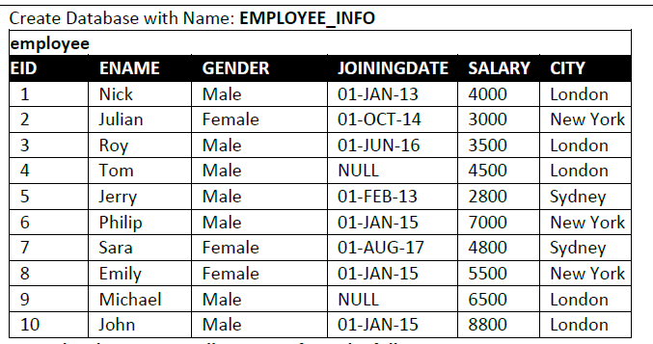

1) Display employees whose gender is Male.

db.Employee.find({Gender:{$eq:”Male”}},{})

2) Display employees who belong to London city.

db.Employee.find({City:{$eq:”Landon”}},{})

3) Display employees whose salary is greater than 3500.

db.Employee.find({salary:{$gt:3500}},{})

4) Display employees whose joining date is before 2015-01-01.

db.Employee.find({JoiningDate:{$lt:”01-01-2015”}},{})

5) Display employees whose EID is greater than or equal to 7.

db.Employee.find({Eid:{$gte:7}},{})

6) Display employees whose city is Landon or New York (use:IN)

db.Employee.find({City:{$in:[”New York”,”London”]}},{})

7) Display employees who do not belongs to Landon or New York (use: NOT IN)

db.Employee.find({City:{$nin:[”New York”,”London”]}},{})

8) Display the EID of those employee who lives in city London.

db.Employee.find({$or:[{City:”London”},{City:”london”}]},{Eid:1})

9) Display first 2 employee names who lives in New york.

db.Employee.find({City:”New York”},{Ename:1}).limit(2)

10) Display next 2 employee after skipping first 2 whose city is London.

db.Employee.find({$or:[{City:”London”},{City:”london”}]},{Ename:1}).skip(2).limit(3)

11) Display Male employees who lives Sydney.

db.Employee.find({$and:[{City:”Sydney”,Gender:”Male”}]},{Ename:1})

12) Display EID, ENAME, CITY and SALARY of those employees who belongs to London or Sydney.

db.Employee.find({$and:[{City:”Sydney”},{City:”London”}]},{Ename:1,Eid:1,salary:1,City:1})

13) Display ENAME, SALARY, and CITY of those employee whose salary is more than 7000.

db.Employee.find({salary:{$gt: 7000}},{Ename:1,salary:1,City:1})

14) Display documents whose name start with E.

db.Employee.find({Ename:/^E/},{})

15) Display documents whose name starts with S or M in your collection.

db.Employee.find({$or:[{Ename:/^S/},{Ename:/^M/}]},{})

16) Display documents where city starts with A to M in your collection.

db.Employee.find({City:/^[A-M]/},{})

17) Display documents where city name ends in ‘ney’.

db.Employee.find({City:/ney$/},{})

18) Display employee info whose name contains n. (Both uppercase(N) and lowercase(n))

db.Employee.find({$or:[{Ename:/[N]/},{Ename:/[n]/}]},{})

19) Display employee info whose name starts with E and having 5 characters.

db.Employee.find({Ename:/^E…. /},{})

20) Display employee whose name start with S and ends in a.

db.Employee.find({$and:[{Ename:/^S/},{Ename:/a$/}]},{})

21) Display EID, ENAME, CITY and SALARY whose name starts with ‘Phi’.

db.Employee.find({Ename:/^Phi/},{Ename:1,Eid:1,salary:1,City:1})

22) Display ENAME, JOININGDATE and CITY whose city contains ‘dne’ as three letters in city name.

db.Employee.find({City:/[dne]/},{Ename:1,City:1,JoiningDate:1})

23) Display ENAME, JOININGDATE and CITY who does not belongs to city London or Sydney.

db.Employee.find({City:{$nin:[“London”,”Sydney”]}},{Ename:1,City:1,JoiningDate:1})

24) Delete the documents whose city is New York.

db.Employee.deleteOne({City:”New York”},{})

25) Update ENAME of Nick to ‘Naysa’ and GENDER to ‘Female’.

db.Employee.updateOne({Ename:”Nick”},{$set:{Ename:”Naysa”}})

Part-B :- Database (Student_info)

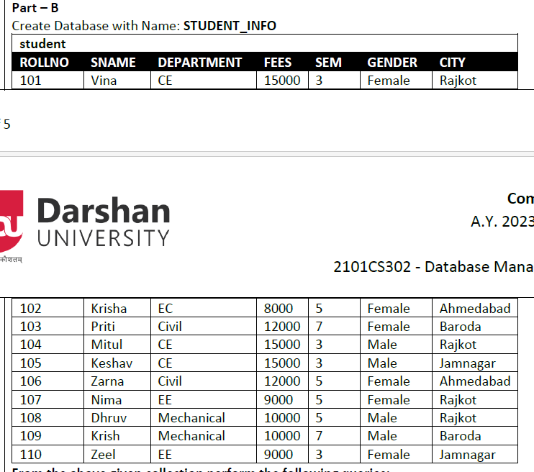

26) Display Female students.

db.student.find({GENDER:”Female”},{})

27) Display students who belong to Rajkot city.

db.student.find({CITY:”Rajkot”},{})

28) Display students studying in 7th sem.

db.student.find({SEM:7},{})

29) Display students not studying in 3rd sem.

db.student.find({SEM:{$nin:[3]}},{})

30) Display students whose roll no is greater than 107.

db.student.find({ROLLNO:{$gt:107}},{})

31) Display students whose city is Jamnagar or Baroda (use:IN)

db.student.find({CITY:{$in:[“Jamnagar”,”Baroda”]}},{})

32) Display students whose fees is less than 9000.

db.student.find({FEES:{$lt:9000}},{})

33) Display the roll no of those students who belongs to Mechanical department.

db.student.find({DEPARTMENT:”Mechanical”},{ROLLNO:1})

34) Display first 2 students names who lives in Baroda.

db.student.find({CITY:”Baroda”},{SNAME:1}).limit(2)

35) Display Male students who studying in 3rd sem.

db.student.find({$and:[{GENDER:”Male”},{SEM:3}]},{})

36) Display sname and city and fees of those students whose roll no is less than 105.

db.student.find({ROLLNO:{$lt:105}},{SNAME:1,CITY:1})

37) Display documents where sname start with K.

db.student.find({SNAME:/^K/},{})

38) Display documents where sname starts with Z or D in your collection.

db.student.find({SNAME:/^[Z,D]/},{})

39) Display documents where city starts with A to R in your collection.

db.student.find({CITY:/^[A-R]/},{})

40) Display students’ info whose name start with P and ends in i.

db.student.find({$and:[{SNAME:/^P /},{SNAME:/i$/}]},{})

41) Display students’ info whose department name starts with ‘C’.

db.student.find({DEPARTMENT:/^C/},{})

42) Display name, sem, fees, and department whose city contains ‘med’ as three letters somewhere in city name.

db.student.find({CITY:/[med]/},{SNAME:1,SEM:1,FEES:1,DEPARTMENT:1})

43) Display name, sem, fees, and department who does not belongs to city Rajkot or Baroda.

db.student.find({City:{$nin:[“Rajkot”,”Baroda”]}},{ SNAME:1,SEM:1,FEES:1,DEPARTMENT:1})

44) Delete the documents whose city is Jamnagar.

db.student.deleteMany({CITY:”Jamnagar”})

45) Update sname of Krish to ‘fenny’ and gender to ‘Female’.

db.student.updateMany({SNAME:”Krish",GENDER:” Male”},{$set:{SNAME:”fenny”,GENDER:”Female”}},{})

Part-C :- Database (Student_info)

46) Display next 2 students after skipping first 2 whose city is Ahmedabad.

db.student.find({CITY:”Ahmedabad”},{}).skip(2).limit(2)

47) Display rollno, sname, fees, and department of those students who is from Baroda and belongs to CE department.

db.student.find({$and:[{CITY:”Baroda”},{DEPARTMENT:”CE”}]},{SNAME:1,ROLLNO:1,FEES:1,DEPARTMENT:1})

48) Display documents where city name ends in ‘oda’.

db.student.find({CITY:/[oda]$/},{})

49) Display students’ info whose name contains v. (Both uppercase(V) and lowercase(v))

db.student.find({SNAME:/[V,v]/},{})

50) Display students’ info whose name starts with V and having 4 characters.

db.student.find({SNAME:/^V… /},{})